IBM SkillsBuild
User Manual

Contents

3-5 | Login and Register
6-7 | Dashboard
8-9 | View All Courses and Favourite Courses
10-12 | Course Page
13 | Popular Courses
14-15 | Daily Challenges
16 | Badges
17  18-19 | Admin Analytics  Leaderboard

1. Login and Register
Upon opening the website, the first page you first interact with will be the login page.
Registering an account
For individuals who do not yet have an account, they should create an account by clicking on the 'register' button.
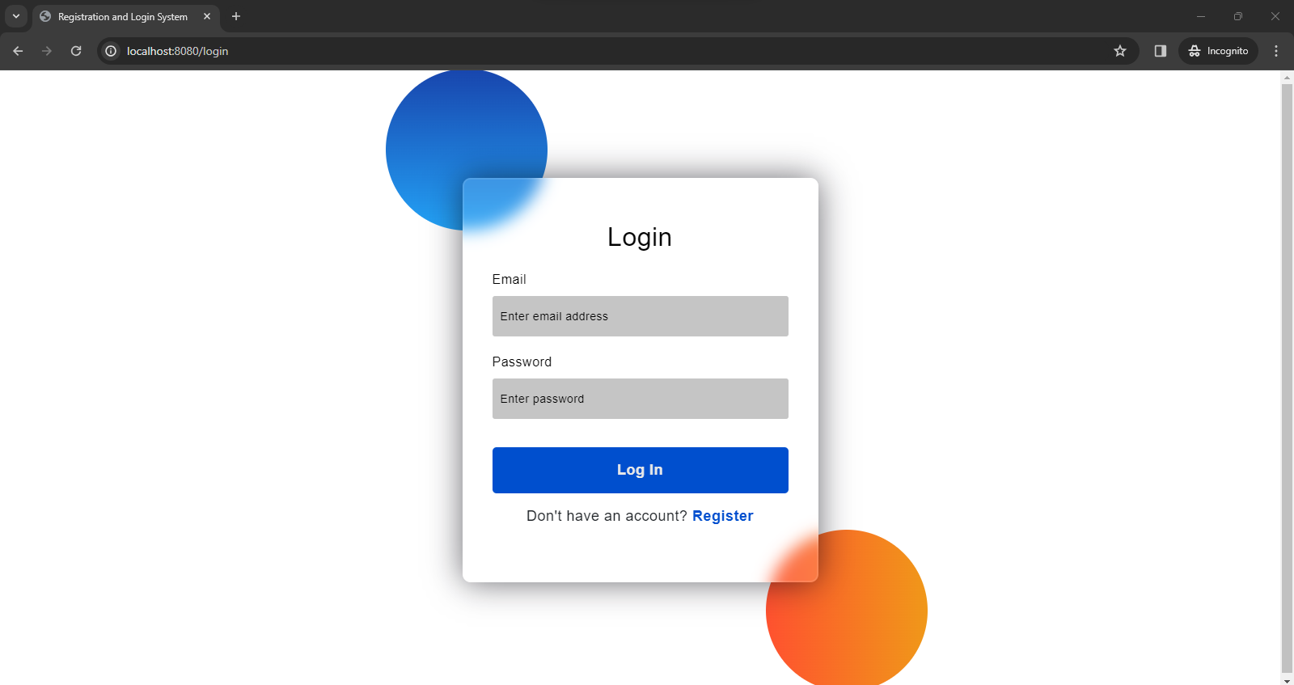
You will see five fields (first name, last name, email, password, role). Fill in all the fields with the appropriate information.
⚠ Your email address should be in the following format: user@email.com (can be .org .co.uk etc.) and must be unique. If an email is already in use, users will be prompted with text indicating that the provided email is already associated with an existing account. In this circumstance, you will have to use another email.
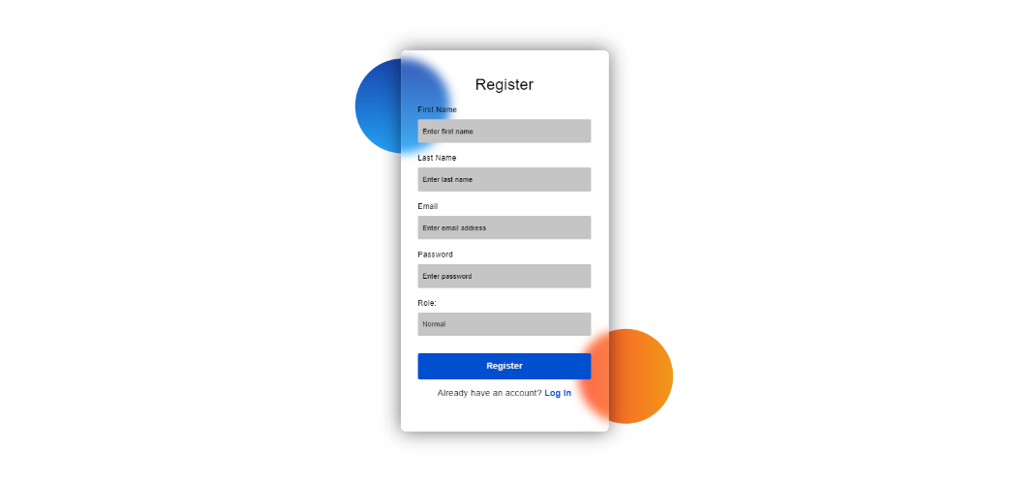

The role field is a drop-down menu – pick the appropriate role to proceed with the registration process.
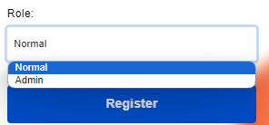

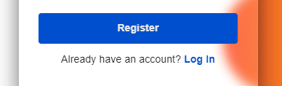
Once you have verified all the information in the register form, you can finalise the process by pressing the “Register” button and this will redirect the user back to the login page.
In the case, where the user already does have an account, an option to redirect the user to the login page is also provided.
Logging into your account
You will be required to fill in your email address and password. Once these fields have been filled in, the “Log In” button will direct you to the dashboard after the system validates the following credentials.
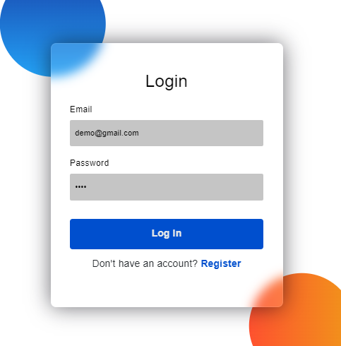

If either the email or password are invalid, you will be prompted with the following messages:
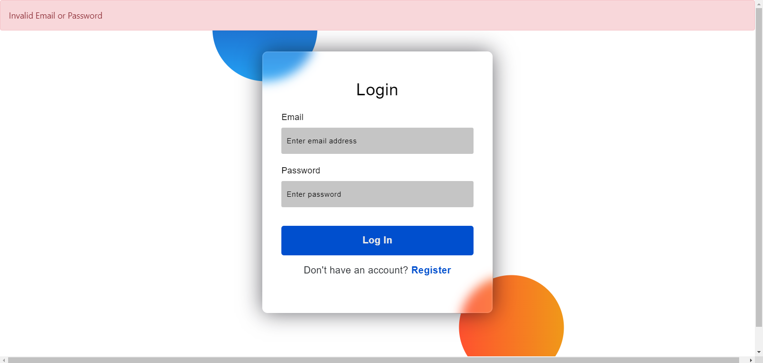
This can occur when either an email is not associated with an existing account or if the password linked to the email is incorrect. You will then have to re-fill the fields with the correct information.

2. Dashboard and Navigation Bar
Once you have successfully logged in, you will be redirected to the main dashboard.
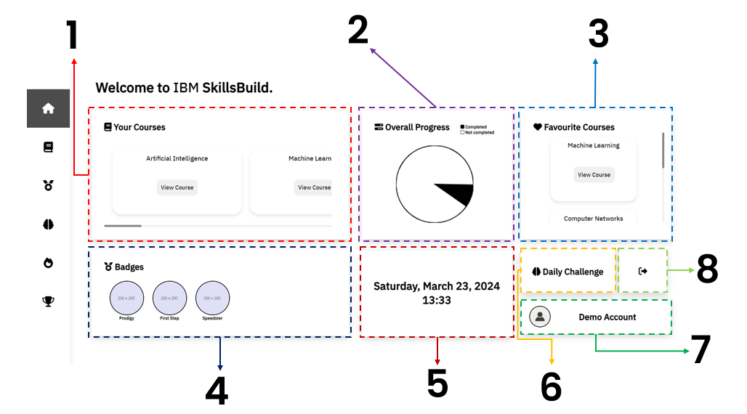
1 | Your Courses box  This box will contain all your available courses. You will be able to access the specific course by pressing “View Course”. You can scroll through all the courses by clicking and dragging the horizontal scroll bar.
2 | Overall Progress box  You can see a visual representation of how many courses you have completed.
3 | Favourite Courses box  Here you can see all the courses you’ve set as your favourites. You can scroll vertically to see the different courses and you can directly access the course pages by pressing “View Course”
4 | Badges box  You can see the badges you’ve earnt here. You can scroll horizontally to see more of your badges.
5 | Time and Date box  Shows real-time Date and time within this section.
6 | Daily Challenge Button  Daily challenge button that directs the user to the daily challenge page.
7 | User Info  Will have the user’s first name and second name
8 | Logout Button  A button that will log the user out and directs them to the login page.
Navigation Bar
The user can also interact with the navigation bar on the left to access specific pages. Each icon corresponds to a different page.
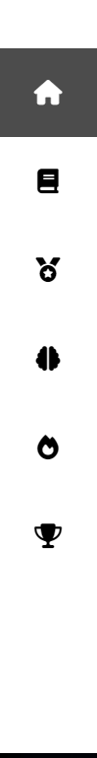
Leaderboard button – will take you to the page where you can view the global leaderboard.
Popular course button – will take you to the popular course page where you can see the top courses.
Daily Challenge button – will take you to the page where you can attempt your daily challenge.
Badges button – will take you to the Badge page, where you will be able to see the badges you’ve earnt, and the badges that have yet to be achieved.
View Courses button – will direct you to a page where you can look at all your courses as well as your favourite courses.
Dashboard button – will take you to the dashboard page
If the button is highlighted grey, this suggests you are currently on the specific page already.

3. View All Courses and Favourite Courses
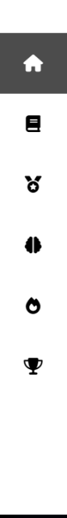
To see all your courses, on the navigation bar on the left, press the course icon.

Once pressed, you will reach the page where you can see all your courses.
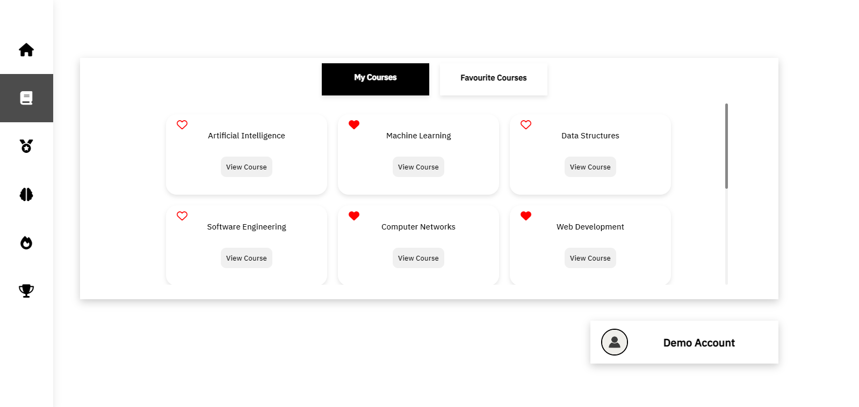
You have access to two tabs. One is My Courses and the other being Favourite Courses.
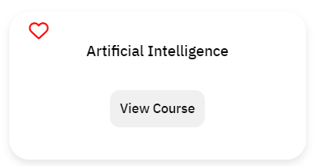

In the My Courses tab, you can see all your courses and find a specific course and go to that that specific course page by clicking view course.


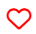
Here you can also set the course as your favourite. When the heart icon is empty, it means the course isn’t favourited and when the heart icon is full, the course is part of your favourites. You can add and remove a course from you favourites by clicking the heart icon.
Not in
favourites
Added to favourites

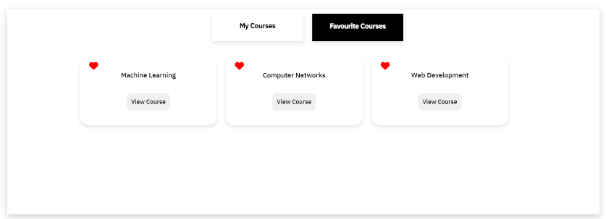
To see all you favourite course, you can click on the Favourite Courses tab. Here you can also view the specific course page. You can also remove the course from your favourites by pressing the heart icon.

4. Course Page
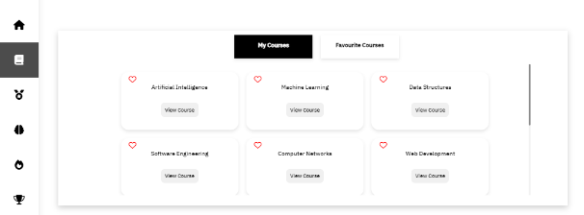
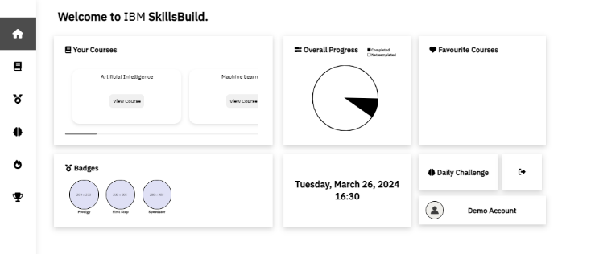
There are two ways of accessing a specific course. You can either access the courses within the dashboard home page or through the course list page.
Course List Page
Dashboard Home
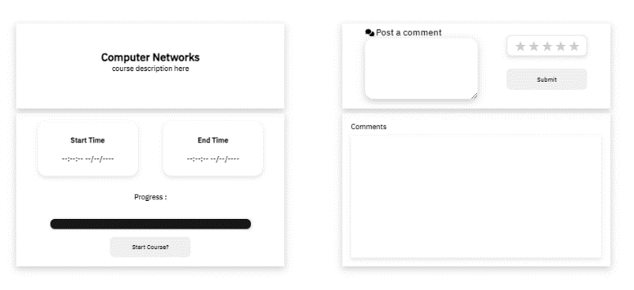

Once you pick a specific course via the “View Course” button, you will gain access to the specific course page.

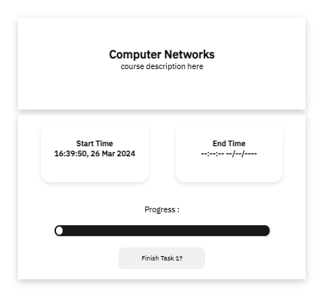

To complete the course, you press “Start Course?” and work your way through the tasks. When you press start course you will also find that your start time will be recorded.

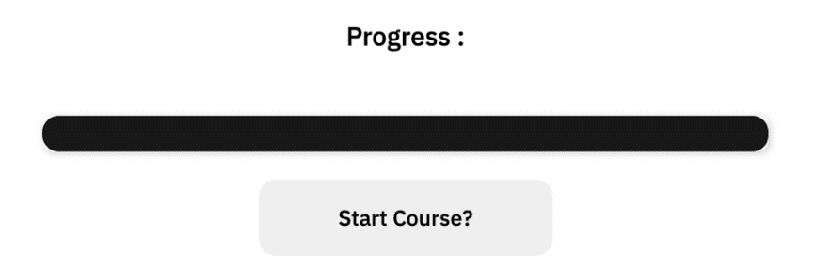
You can track your progress using the progress bar that serves as a visual representation of your advancement through the course. It is displayed horizontally at the bottom of the page.

The progress bar fills up gradually as you complete various tasks of the courses. When you start the course, the progress bar will be empty, indicating 0% completion.
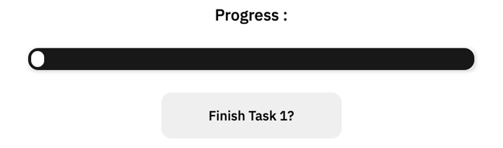

As you advance through the tasks, the progress bar will fill up proportionally to the percentage of tasks available.
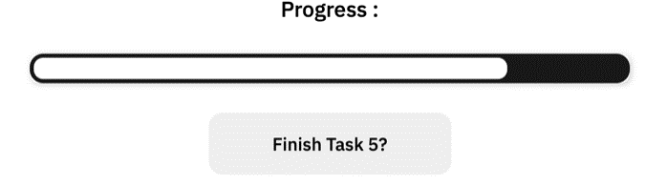

When you've completed all course requirements, the progress bar will be filled to 100%.
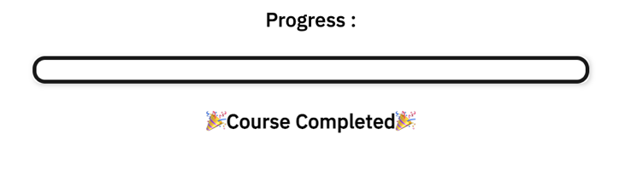

The system will also record your end time upon completion.
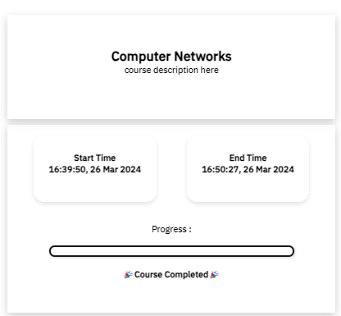

Commenting and rating on a course
Once completing a course, a user can comment and leave a rating on that specific
course.
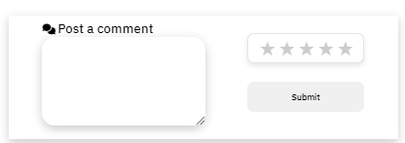
To post a comment and rating, input your comment to the input box.

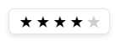
Once you have inputted your text, you must leave a rating in-order for the system to add your comment. You can click on the stars depending on your desired rating.
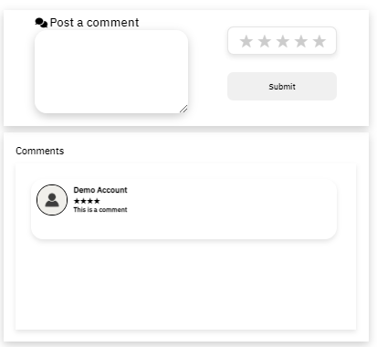
To finalise the process, you click on the submit button. You will see if you comment has been submitted if your comment is within the comment section.

Note: You will be alerted if you have not completed the course and you will be alerted if you fail to leave a rating when posting a comment.
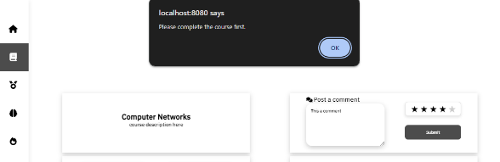
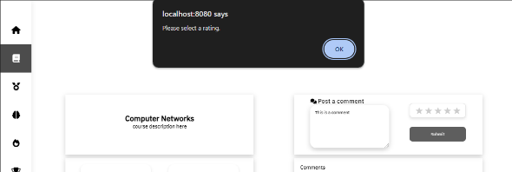

5. Popular Courses
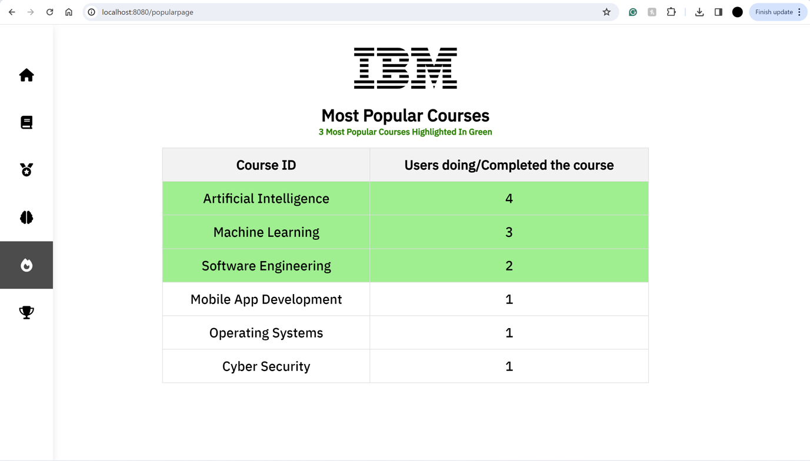
- From the navigation bar you can click on the fire icon to access the popular courses page.
- On this page you will be presented with a table of the courses that users are currently completing or already have completed.
- The courses are ordered in the table as follows: the course with the most users will be at the top, and the course with the least users will be at the bottom.
- The top 3 courses are coloured in green to highlight them from the rest.
- If you want to be redirected to the course page, you can click on the course name.

6. Daily Challenges

From the dashboard the user can click the on the ‘Daily Challenge’ button which will direct them to a unique challenge for the day.


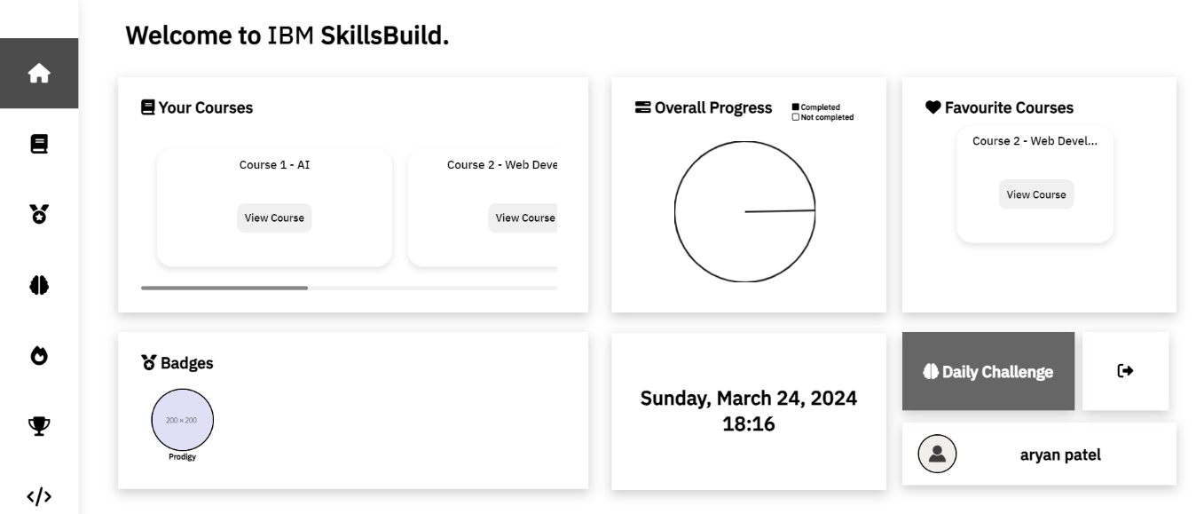

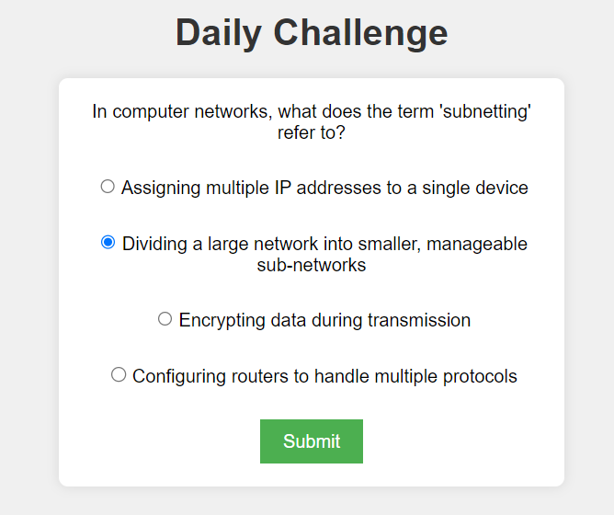
A challenge is displayed which will always consist of the question and 4 multiple choice answers.
Only 1 radio button can be pressed and you will not be able to submit until an option is selected.
After pressing submit you will be redirected to the appropriate page to let you know if your answer is correct.

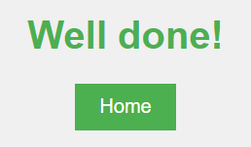
If the user answers correctly they are redirected to this page which notifies them the answer is correct.

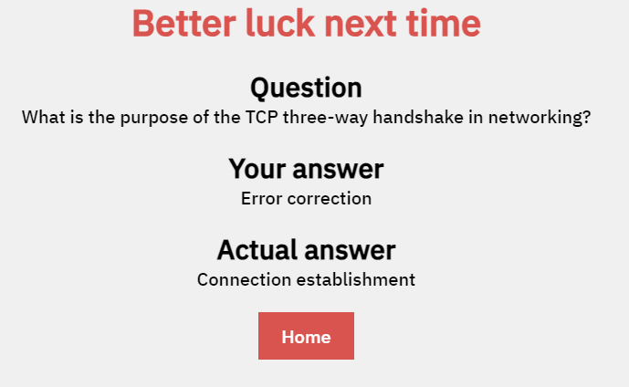

If the user answers incorrectly they are redirected to this page which gives them a review of the question showing the correct answer

7. Badges
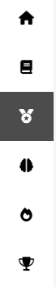

On the dashboard, find the "Badges" icon on the navbar.

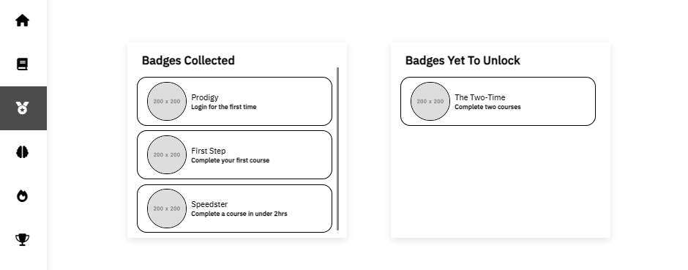
Once you’ve pressed on the badge icon, you will reach the badge page. Here you will see all the badges you have earnt and badges that can be unlocked.

Upon satisfying a condition for the badges, the badges will be added to the “Badges Collected” section.

8. Admin Analytics
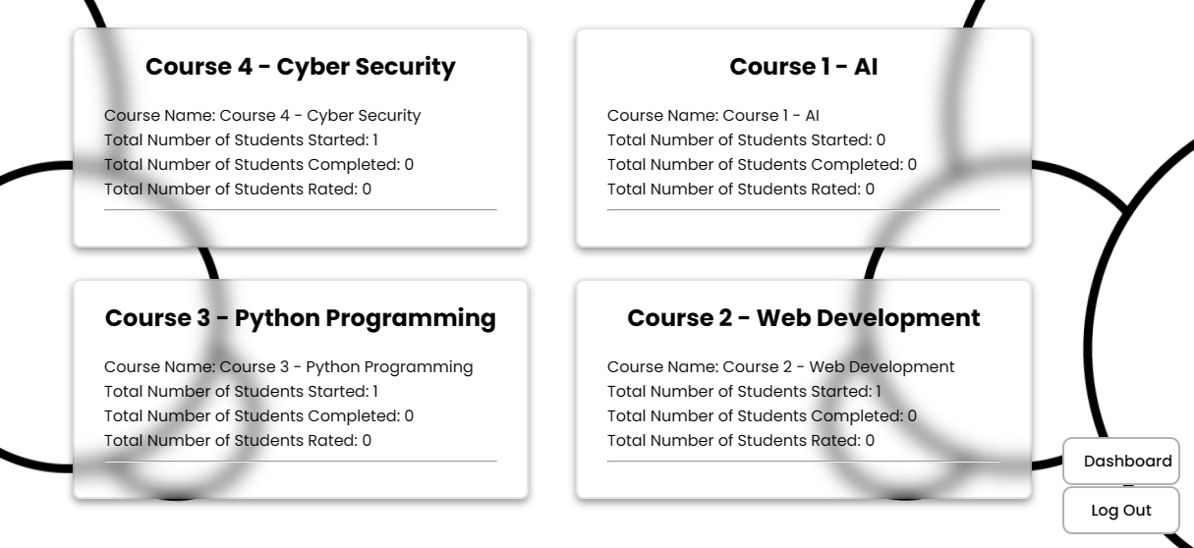
This page is exclusive to Admins only and allow them to see the data regarding each course. Such as total number of students that started a course, total number of students completed the course and total number of students that rated the course.

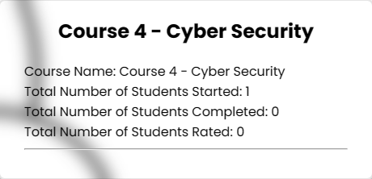

This card format allows the admin to see the level of engagement with each course in a clear and concise manner.

9. Leaderboard
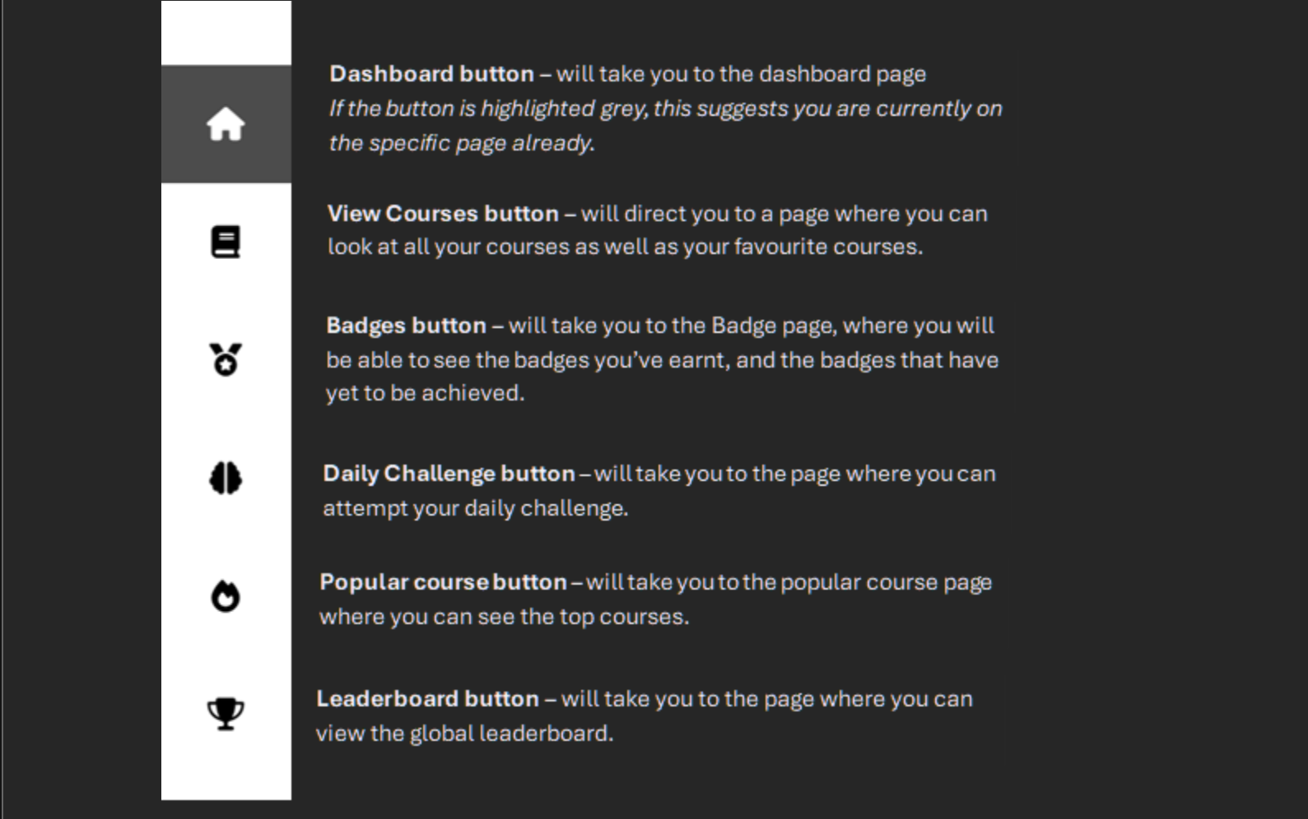
To see the current rankings in the Global Leaderboard, on the navigation bar on the left, press the trophy icon.

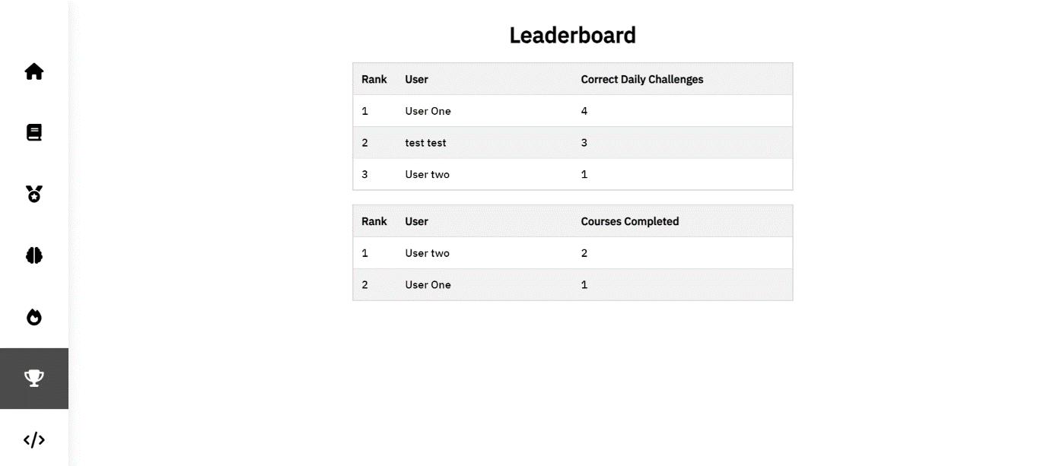
Once pressed, you will reach the page displaying the current rankings on the leaderboard table.
3
1
2
- This leaderboard shows the number of daily challenges completed correctly by each user
- This leaderboard displays the number of courses completed by each user
- Nav bar on the left for easy navigation for the user

